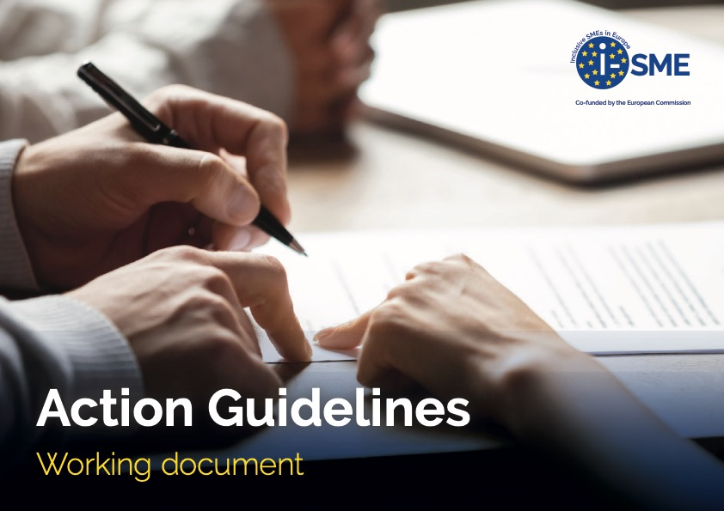

Working document Action Guidelines

Version:
Author:
Date meeting:

Explanation event and the ‘why’ of this event: Explain here your ideas about the event and why you organise the event:

Who is our audience? | What is our ambition with this audience? | What type of event shall we organise? | Who will organise?
Why do we choose this audience? | Why is this our ambition? | Why do we choose for this type of event? | Why do ‘they’ organise?
What SMART goal(s) do we want to reach:

Make use of the Ingredients part I

What shall we organise | Where shall I organise? | What to include in the programme?
Why do we organise this in this way? | Why do we organise it there? | Why do we include this in the programme?

Make use of the Ingredients part II

Who is best to speak | What should be the message | What else to include to ensure the highest chance on success
Why is this person best to speak? | Why is this the message? | Why do we include these ingredients?

Measuring Success: What to do in the end to find out if we reached our goal(s)?

Risk Analysis
Possible Risks | How to encounter

Activity list: who does what and when is it done
What needs to be done | Who is responsible | When is it done

Other things to think about:

